The Grid System is probably the number one reason why people use bootstrap. The Grid System will act as the skeleton of our entire application. Its easy to add structure and lay out to our application.

Basically, using the Grid System we can say that we want some content to take up 100% of the screen and we can also use it to say that we want each of four contents side by side to take 25% of the width of the screen, until we shrink our screen to mobile or tablet size and each content takes up to 50% of the width of the screen and then when we hit mobile they each takes up 100%.

It lets us divide the screen into pieces and lets us pick how many pieces we want each of our own elements to take up.

Every **container** in bootstrap can be divided into 12 different columns and then using the Grid System we can pick how many of those 12 units each element should take up.

Anytime we use a Bootstrap Grid it needs to be inside a container.

HTML

*<!DOCTYPE html>*

*<htm>*

*<head>*

*<title>Bootstrap Grid</title>*

*<link rel= “stylesheet” type= “text/css” href=* [*https://maxcdn.bootstrapcdn.com/bootstrap/3.3.5/css/bootstrap.min.css*](https://maxcdn.bootstrapcdn.com/bootstrap/3.3.5/css/bootstrap.min.css)*>*

*</head>*

*<body>*

*<!-- ========================================== 🡪*

*<!-- OBJECTIVES 🡪*

*<!—1. Understand Purpose of Grid System 🡪*

*<! – 2. Understand the 4 different sizes 🡪*

*<!—3. Write Nested Grids 🡪*

*<!-- ====================================== 🡪*

*<div class= “container”>*

*<div class= “row”>*

*<div class= “col-lg-6”>COL LG 6</div>*

*<div class= “col-lg-6”>COL LG 6</div>*

*</div>*

*</div>*

*</body>*

*</html>*

|  |  |
| --- | --- |
| *COL LG 6* | *COL LG 6* |

*<div class= “container”>*

*<div class= “row”>*

*<div class= “col-lg-2”>COL LG 2</div>*

*<div class= “col-lg-8”>COL LG 8</div>*

*<div class= “col-lg-2”>COL LG 2</div>*

*</div>*

*</div>*

|  |  |  |
| --- | --- | --- |
| *COL LG 2* | *COL LG 8* | *COL LG 2* |

*<div class= “container”>*

*<div class= “row”>*

*<div class= “col-lg-1”>COL LG 1</div>*

*<div class= “col-lg-1”>COL LG 1</div>*

*<div class= “col-lg-1”>COL LG 1</div>*

*<div class= “col-lg-1”>COL LG 1</div>*

*<div class= “col-lg-1”>COL LG 1</div>*

*<div class= “col-lg-1”>COL LG 1</div>*

*<div class= “col-lg-1”>COL LG 1</div>*

*<div class= “col-lg-1”>COL LG 1</div>*

*<div class= “col-lg-1”>COL LG 1</div>*

*<div class= “col-lg-1”>COL LG 1</div>*

*<div class= “col-lg-1”>COL LG 1</div>*

*<div class= “col-lg-1”>COL LG 1</div>*

*</div>*

*</div>*

|  |  |  |  |  |  |  |  |  |  |  |  |
| --- | --- | --- | --- | --- | --- | --- | --- | --- | --- | --- | --- |
|  |  |  |  |  |  |  |  |  |  |  |  |

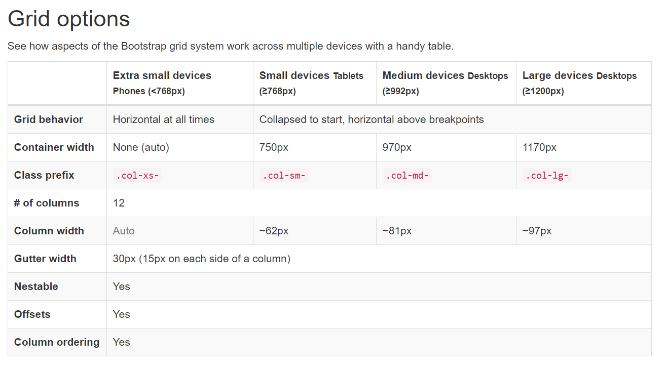

*<div class= “container”>*

*<div class= “row”>*

*<div class= “col-lg-1 col-md-2”>COL LG 1</div>*

*<div class= “col-lg-1 col-md-2”>COL LG 1</div>*

*<div class= “col-lg-1 col-md-2”>COL LG 1</div>*

*<div class= “col-lg-1 col-md-2”>COL LG 1</div>*

*<div class= “col-lg-1 col-md-2”>COL LG 1</div>*

*<div class= “col-lg-1 col-md-2”>COL LG 1</div>*

*<div class= “col-lg-1 col-md-2”>COL LG 1</div>*

*<div class= “col-lg-1 col-md-2”>COL LG 1</div>*

*<div class= “col-lg-1 col-md-2”>COL LG 1</div>*

*<div class= “col-lg-1 col-md-2”>COL LG 1</div>*

*<div class= “col-lg-1 col-md-2”>COL LG 1</div>*

*<div class= “col-lg-1 col-md-2”>COL LG 1</div>*

*</div>*

*</div>*

We added an extra class to each of the divs, these class is added to make the screen friendly for tablet users. When the large screen is minimized to a medium screen, we will have 2 units going across instead of 1 unit. The view of the medium screen is shown below:

|  |  |  |  |  |  |
| --- | --- | --- | --- | --- | --- |
| COL-MD-2 | COL-MD-2 | COL-MD-2 | COL-MD-2 | COL-MD-2 | COL-MD-2 |
| COL-MD-2 | COL-MD-2 | COL-MD-2 | COL-MD-2 | COL-MD-2 | COL-MD-2 |

*<div class= “row”>*

*<div class= “col-lg-3 col-md-3 col-sm-6”>TOUR DATE!</div>*

*<div class= “col-lg-3 col-md-3 col-sm-6”>TOUR DATE!</div>*

*<div class= “col-lg-3 col-md-3 col-sm-6”>TOUR DATE!</div>*

*<div class= “col-lg-3 col-md-3 col-sm-6”>TOUR DATE!</div>*

*</div>*

According to the above code each content will take 3 units till we hit small and once we hit small each content will take 6 units as shown below:

|  |  |
| --- | --- |
| TOUR DATE! | TOUR DATE! |
| TOUR DATE! | TOUR DATE! |

Other than that, each content will take 12 units when we hit extra small as shown below:

|  |
| --- |
| TOUR DATE! |
| TOUR DATE! |
| TOUR DATE! |
| TOUR DATE! |

*<https://getbootstrap.com/docs/4.0/layout/grid/>*

[*https://getbootstrap.com/docs/3.4/css/*](https://getbootstrap.com/docs/3.4/css/)

[*https://bootstrapdocs.com/v3.3.5/docs/css/*](https://bootstrapdocs.com/v3.3.5/docs/css/)